**Terraform Task 2**

**Task Description:**

**Create 2 EC2 instances on 2 different regions and install nginx using terraform script.**

Step 1: Launch the EC2 instances and install the Terraform.

**sudo apt update && sudo apt install -y wget unzip**

**wget https://releases.hashicorp.com/terraform/1.11.2/terraform_1.11.2_linux_amd64.zip**

**unzip terraform_1.11.2_linux_amd64.zip**

**sudo mv terraform /usr/local/bin/**

**terraform --version # Verify installation**

**Step 2: Configure AWS CLI**

Terraform needs AWS credentials to create resources.

1. Install AWS CLI (if not installed):

**sudo apt update && sudo apt install awscli -y**

**2. curl "https://awscli.amazonaws.com/awscli-exe-linux-x86_64.zip" -o "awscliv2.zip"**

**unzip awscliv2.zip**

**sudo ./aws/install**

3. **aws --version**

2. Configure AWS credentials:

**AWS configure**

Enter your AWS Access Key, Secret Key, but don’t configure the access key and secret key because when we need to use multiple regions.

**Step 3: Create terraform file which create 2 EC2 instances on 2 different regions and install nginx.**

For this we need to create a terraform workspace for create environments so we can use same terraform file for multiple regions.

1. First create a virtual environments ProjectA and ProjectB. Using Terraform workspace method.

1. Now Create a main.tf, provider.tf and variable.tf files in workspace directory.

1. Select the virtual environment to run the terraform infrastructure

1. Terraform init.

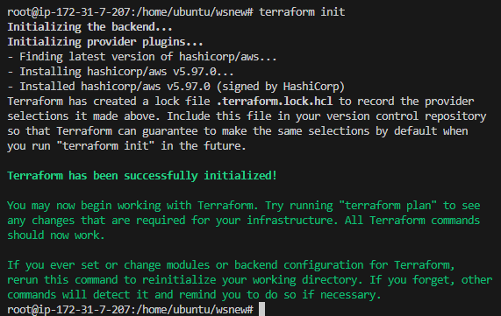

1. Terraform plan

1. Terraform apply -auto-approve

1. Now check the AWS console ap-south-1 region will have one EC2.

1. Now switch to projectB and repeat the types.

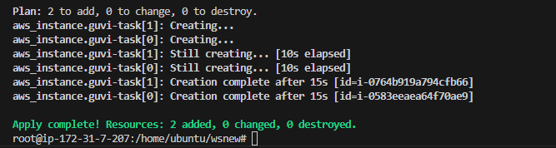

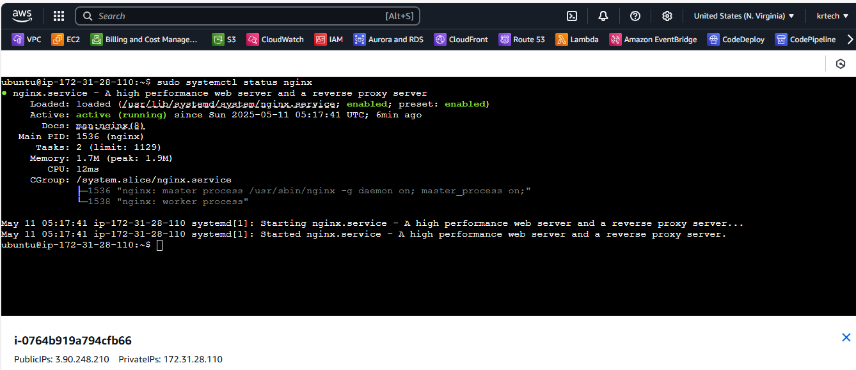

Now two EC2 instance created in two regions with nginx but same main.tf file.